**22BCE0476**

**AMAN CHAUHAN**



BCSE308P - Computer Networks Lab

LAB REPORT

DA-4 Socket Programming

**3. Socket**

1. UDP socket

2. TCP socket

3. HTTP TCP

4. Echo TCP

5. ARP TCP

6. RARP TCP

7. Chat TCP

8. File Transfer TCP

9. DNS TCP

10. Multiuser chat TCP

11. Math server TCP

1. UDP socket programs:

Server:

import socket  
  
def udp_server():  
 # Create a UDP socket and bind it to port 9876  
 server_socket = socket.socket(socket.AF_INET, socket.SOCK_DGRAM)  
 server_socket.bind(('localhost', 9876))  
 print("Server is up and running")  
  
 while True:  
 # Receive data from the client  
 receive_data, client_address = server_socket.recvfrom(1024)  
 sentence = receive_data.decode('utf-8').strip()  
 print(f"Received from client: {sentence}")  
  
 # Process the data (convert to uppercase)  
 capitalized_sentence = sentence.upper()  
 send_data = capitalized_sentence.encode('utf-8')  
  
 # Send the response back to the client  
 server_socket.sendto(send_data, client_address)  
 print(f"Sent to client: {capitalized_sentence}")  
  
if __name__ == "__main__":  
 udp_server()

Client:

import socket  
  
def udp_client():  
 # Create a UDP socket  
 client_socket = socket.socket(socket.AF_INET, socket.SOCK_DGRAM)  
 server_address = ('localhost', 9876)  
  
 # Get input from the user  
 sentence = input("Enter a string to convert to uppercase: ")  
 send_data = sentence.encode('utf-8')  
  
 # Send data to the server  
 client_socket.sendto(send_data, server_address)  
  
 # Receive response from the server  
 receive_data, _ = client_socket.recvfrom(1024)  
 capitalized_sentence = receive_data.decode('utf-8').strip()  
 print(f"From server: {capitalized_sentence}")  
  
 # Close the client socket  
 client_socket.close()  
  
if __name__ == "__main__":  
 udp_client()

Output:

Server output:

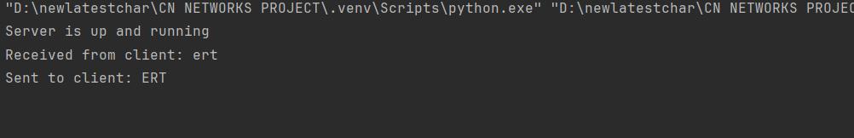

Client output:

2. TCP socket:

Server:

import socket  
import os  
  
def tcp_server():  
 # Set up the server socket to listen on port 4000  
 server_socket = socket.socket(socket.AF_INET, socket.SOCK_STREAM)  
 server_socket.bind(('localhost', 4000))  
 server_socket.listen(1)  
 print("Server is ready for connection")  
  
 # Accept a connection from a client  
 client_socket, client_address = server_socket.accept()  
 print("Connection established with:", client_address)  
  
 # Receive the filename from the client  
 file_name = client_socket.recv(1024).decode('utf-8').strip()  
 print(f"Client requested file: {file_name}")  
  
 try:  
 # Check if the file exists and read its contents  
 if os.path.isfile(file_name):  
 with open(file_name, 'r') as file:  
 for line in file:  
 client_socket.sendall(line.encode('utf-8'))  
 print(f"Sent line to client: {line.strip()}")  
 else:  
 client_socket.sendall(b"File not found.")  
 print("File not found.")  
  
 except Exception as e:  
 print(f"An error occurred: {e}")  
  
 finally:  
 # Close the connections  
 client_socket.close()  
 server_socket.close()  
 print("Server closed the connection.")  
  
if __name__ == "__main__":  
 tcp_server()

Client:

import socket  
  
def tcp_client():  
 # Connect to the server running on localhost at port 4000  
 server_address = ('localhost', 4000)  
 client_socket = socket.socket(socket.AF_INET, socket.SOCK_STREAM)  
 client_socket.connect(server_address)  
  
 # Get the filename from the user  
 file_name = input("Enter the filename: ")  
 client_socket.sendall(file_name.encode('utf-8'))  
  
 # Receive the file content from the server and display it  
 try:  
 while True:  
 data = client_socket.recv(1024)  
 if not data:  
 break  
 print(data.decode('utf-8'), end="")  
  
 except Exception as e:  
 print(f"An error occurred: {e}")  
  
 finally:  
 # Close the client socket  
 client_socket.close()  
 print("\nClient closed the connection.")  
  
if __name__ == "__main__":  
 tcp_client()

Output:

Server output:

Client output:

3. HTTP TCP:

import requests  
import os  
  
def download_web_page(url, file_path="D:/newlatestchar/CN NETWORKS PROJECT/DownloadedPage.html"):  
 try:  
 # Ensure the directory exists  
 os.makedirs(os.path.dirname(file_path), exist_ok=True)  
  
 # Send a GET request to the URL with a user-agent header  
 headers = {  
 "User-Agent": "Mozilla/5.0 (Windows NT 10.0; Win64; x64) AppleWebKit/537.36 (KHTML, like Gecko) Chrome/86.0.4240.183 Safari/537.36"  
 }  
 response = requests.get(url, headers=headers, timeout=10)  
  
 # Check if the request was successful (status code 200)  
 if response.status_code == 200:  
 # Write the page content to a file with the specified encoding  
 with open(file_path, "w", encoding="utf-8") as file:  
 file.write(response.text)  
 print(f"Successfully downloaded the webpage to {file_path}")  
 else:  
 print(f"Failed to retrieve webpage. Status code: {response.status_code}")  
  
 except requests.exceptions.MissingSchema:  
 print("Invalid URL format. Please check the URL.")  
 except requests.exceptions.ConnectionError:  
 print("Failed to establish a connection. Please check the URL or your internet connection.")  
 except requests.exceptions.Timeout:  
 print("The request timed out. Please try again later.")  
 except requests.exceptions.RequestException as e:  
 print(f"An error occurred: {e}")  
 except Exception as e:  
 print(f"An unexpected error occurred: {e}")  
  
if __name__ == "__main__":  
 url = "https://www.google.com/"  
 download_web_page(url)

Output

4. Echo TCP:

Server:

import socket  
  
  
class EchoServer:  
 def __init__(self, host='127.0.0.1', port=9999):  
 self.server_socket = socket.socket(socket.AF_INET, socket.SOCK_STREAM)  
 self.server_socket.bind((host, port))  
 self.server_socket.listen(1)  
 print(f"Server started. Listening on port {port}")  
  
 def serve(self):  
 try:  
 while True:  
 client_socket, client_address = self.server_socket.accept()  
 print(f"Client connected from {client_address}")  
  
 client_socket.sendall("Welcome to the Python EchoServer. Type 'bye' to close.\n".encode())  
 while True:  
 message = client_socket.recv(1024).decode()  
 if message.strip().lower() == 'bye':  
 print("Client disconnected.")  
 break  
 print(f"Received from client: {message}")  
 client_socket.sendall(f"Got: {message}".encode())  
  
 client_socket.close()  
 except Exception as e:  
 print(f"Error: {e}")  
 finally:  
 self.server_socket.close()  
 print("Server closed.")  
  
  
if __name__ == "__main__":  
 server = EchoServer()  
 server.serve()

Client:

import socket  
  
  
class EchoClient:  
 def __init__(self, host='127.0.0.1', port=9999):  
 self.client_socket = socket.socket(socket.AF_INET, socket.SOCK_STREAM)  
 self.client_socket.connect((host, port))  
 print("Connected to the server. Type 'bye' to end the connection.")  
  
 def chat(self):  
 try:  
 # Receive the initial welcome message from the server  
 welcome_message = self.client_socket.recv(1024).decode()  
 print("Server:", welcome_message)  
  
 while True:  
 message = input("You: ")  
 self.client_socket.sendall(message.encode())  
  
 if message.strip().lower() == 'bye':  
 print("Disconnected from server.")  
 break  
  
 response = self.client_socket.recv(1024).decode()  
 print("Server:", response)  
 except Exception as e:  
 print(f"Error: {e}")  
 finally:  
 self.client_socket.close()  
  
  
if __name__ == "__main__":  
 client = EchoClient()  
 client.chat()

Output:

Server output:

Client output:

5. ARP TCP:

Server:

import socket  
  
class ARPServer:  
 def __init__(self, host='127.0.0.1', port=5604):  
 self.server_socket = socket.socket(socket.AF_INET, socket.SOCK_STREAM)  
 self.server_socket.bind((host, port))  
 self.server_socket.listen(1)  
 print(f"ARP Server started and listening on port {port}")  
  
 def serve(self):  
 # Predefined IP to MAC address mapping  
 ip_to_mac = {  
 "165.165.80.80": "6A:08:AA:C2",  
 "165.165.79.1": "8A:BC:E3:FA"  
 }  
  
 try:  
 while True:  
 client_socket, client_address = self.server_socket.accept()  
 print(f"Client connected from {client_address}")  
  
 # Receive IP address from client  
 ip_address = client_socket.recv(1024).decode().strip()  
 print(f"Received IP Address: {ip_address}")  
  
 # Send corresponding MAC address if found  
 mac_address = ip_to_mac.get(ip_address, "MAC address not found")  
 client_socket.sendall(mac_address.encode())  
 print(f"Sent MAC Address: {mac_address}")  
  
 client_socket.close()  
 print("Client disconnected.")  
 except Exception as e:  
 print(f"Error: {e}")  
 finally:  
 self.server_socket.close()  
 print("Server closed.")  
  
if __name__ == "__main__":  
 server = ARPServer()  
 server.serve()

Client:

import socket  
  
  
class ARPClient:  
 def __init__(self, host='127.0.0.1', port=5604):  
 self.client_socket = socket.socket(socket.AF_INET, socket.SOCK_STREAM)  
 self.client_socket.connect((host, port))  
 print("Connected to ARP server.")  
  
 def request_mac_address(self, ip_address):  
 try:  
 # Send IP address to the server  
 self.client_socket.sendall(ip_address.encode())  
  
 # Receive MAC address from the server  
 mac_address = self.client_socket.recv(1024).decode().strip()  
 print(f"The Physical Address (MAC) for {ip_address} is: {mac_address}")  
 except Exception as e:  
 print(f"Error: {e}")  
 finally:  
 self.client_socket.close()  
 print("Disconnected from server.")  
  
  
if __name__ == "__main__":  
 client = ARPClient()  
 ip_address = input("Enter the Logical address (IP): ")  
 client.request_mac_address(ip_address)

Output:

Server output:

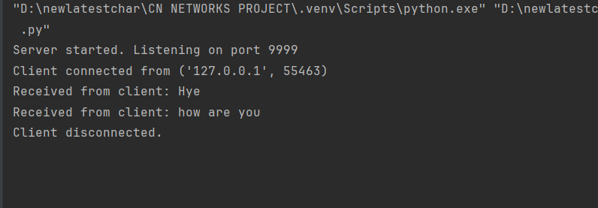

Client output:

6. RARP TCP:

Server:

import socket  
  
def main():  
 try:  
 # Create a UDP socket  
 server_socket = socket.socket(socket.AF_INET, socket.SOCK_DGRAM)  
 server_socket.bind(('localhost', 1309))  
 print("Server is listening...")  
  
 # Define the MAC to IP mapping  
 mac_to_ip = {  
 "6A:08:AA:C2": "165.165.80.80",  
 "8A:BC:E3:FA": "165.165.79.1"  
 }  
  
 while True:  
 # Receive the MAC address from client  
 data, client_address = server_socket.recvfrom(1024)  
 mac_address = data.decode().strip()  
 print(f"Received MAC address: {mac_address}")  
  
 # Find the corresponding IP address  
 ip_address = mac_to_ip.get(mac_address, "Not found")  
 print(f"Sending IP address: {ip_address}")  
  
 # Send the IP address back to client  
 server_socket.sendto(ip_address.encode(), client_address)  
 except Exception as e:  
 print(f"Server Error: {e}")  
 finally:  
 server_socket.close()  
  
if __name__ == "__main__":  
 main()

Client:

import socket  
  
def main():  
 try:  
 # Create a UDP socket  
 client_socket = socket.socket(socket.AF_INET, socket.SOCK_DGRAM)  
  
 # Server address and port  
 server_address = ('localhost', 1309)  
  
 # Get MAC address input from the user  
 mac_address = input("Enter the Physical address (MAC): ").strip()  
 print(f"Sending MAC address: {mac_address}")  
  
 # Send MAC address to the server  
 client_socket.sendto(mac_address.encode(), server_address)  
  
 # Receive IP address from the server  
 data, _ = client_socket.recvfrom(1024)  
 ip_address = data.decode().strip()  
 print(f"The Logical Address is (IP): {ip_address}")  
 except Exception as e:  
 print(f"Client Error: {e}")  
 finally:  
 client_socket.close()  
  
if __name__ == "__main__":  
 main()

Output:

Server output:

Client output:

7. Chat TCP:

Server:

import socket  
  
  
def start_server():  
 # Create a server socket, bind to port 2000, and listen for incoming connections  
 server_socket = socket.socket(socket.AF_INET, socket.SOCK_STREAM)  
 server_socket.bind(('0.0.0.0', 2000))  
 server_socket.listen(1)  
 print("Server is listening on port 2000...")  
  
 # Accept a connection from a client  
 client_socket, client_address = server_socket.accept()  
 print(f"Connected to {client_address}")  
  
 # Create input and output streams for communication  
 client_input = client_socket.makefile('r')  
 client_output = client_socket.makefile('w')  
  
 while True:  
 # Read message from client  
 client_message = client_input.readline().strip()  
 if client_message.lower() == "end":  
 client_output.write("BYE\n")  
 client_output.flush()  
 break  
 print(f"Client: {client_message}")  
  
 # Respond to client  
 server_message = input("Server: ")  
 client_output.write(server_message + "\n")  
 client_output.flush()  
  
 # Close the connections  
 client_input.close()  
 client_output.close()  
 client_socket.close()  
 server_socket.close()  
  
  
# Start the server  
start_server()

Client:

import socket  
  
def start_client():  
 # Create a client socket and connect to the server at localhost on port 2000  
 client_socket = socket.socket(socket.AF_INET, socket.SOCK_STREAM)  
 client_socket.connect(('127.0.0.1', 2000))  
  
 # Create input and output streams for communication  
 server_input = client_socket.makefile('r')  
 server_output = client_socket.makefile('w')  
  
 while True:  
 # Get message from user to send to server  
 client_message = input("Client: ")  
 server_output.write(client_message + "\n")  
 server_output.flush()  
  
 # Read response from server  
 server_message = server_input.readline().strip()  
 print(f"Server: {server_message}")  
  
 if server_message.lower() == "bye":  
 break  
  
 # Close the connection  
 server_input.close()  
 server_output.close()  
 client_socket.close()  
  
# Start the client  
start_client()

Output:

Server output:

Client output:

8. File Transfer TCP:

Server:

import socket  
import os  
  
def start_server():  
 server_socket = socket.socket(socket.AF_INET, socket.SOCK_STREAM)  
 server_socket.bind(('localhost', 5000))  
 server_socket.listen(1)  
 print("Server listening on port 5000...")  
  
 client_socket, client_address = server_socket.accept()  
 print(f"Connection established with {client_address}")  
  
 file_path = "hello.txt"  
 file_size = os.path.getsize(file_path)  
 with open(file_path, 'rb') as file:  
 bytes_sent = 0  
 while bytes_sent < file_size:  
 # Read in chunks of 10000 bytes  
 chunk = file.read(10000)  
 client_socket.send(chunk)  
 bytes_sent += len(chunk)  
 print(f"Sending file... {(bytes_sent * 100) // file_size}% complete")  
  
 client_socket.close()  
 server_socket.close()  
 print("File sent successfully!")  
  
# Start the server  
start_server()

Client:

import socket  
  
def start_client():  
 client_socket = socket.socket(socket.AF_INET, socket.SOCK_STREAM)  
 client_socket.connect(('localhost', 5000))  
  
 file_path = "received_Text.txt"  
 with open(file_path, 'wb') as file:  
 while True:  
 data = client_socket.recv(10000)  
 if not data:  
 break  
 file.write(data)  
  
 client_socket.close()  
 print("File saved successfully!")  
  
# Start the client  
start_client()

Output:

Server output:

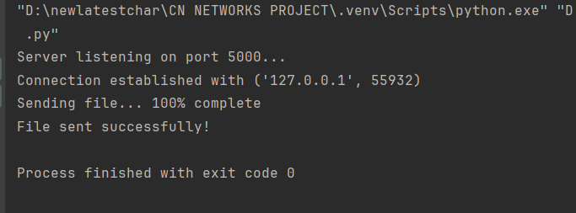

Client output:

9. DNS TCP:

Server:

import socket  
  
  
def index_of(array, str):  
 str = str.strip()  
 for i in range(len(array)):  
 if array[i] == str:  
 return i  
 return -1  
  
  
def start_server():  
 hosts = ["zoho.com", "gmail.com", "google.com", "facebook.com"]  
 ip = ["172.28.251.59", "172.217.11.5", "172.217.11.14", "31.13.71.36"]  
  
 server_socket = socket.socket(socket.AF_INET, socket.SOCK_DGRAM)  
 server_socket.bind(('localhost', 1362))  
 print("DNS Server is running. Press Ctrl+C to quit.")  
  
 while True:  
 # Receive data from client  
 data, client_address = server_socket.recvfrom(1024)  
 request_host = data.decode('utf-8')  
 print(f"Request for host: {request_host}")  
  
 # Find the IP for the requested host  
 if index_of(hosts, request_host) != -1:  
 response = ip[index_of(hosts, request_host)]  
 else:  
 response = "Host Not Found"  
  
 # Send the response back to the client  
 server_socket.sendto(response.encode('utf-8'), client_address)  
  
  
# Start the server  
start_server()

Client:

import socket  
  
def start_client():  
 client_socket = socket.socket(socket.AF_INET, socket.SOCK_DGRAM)  
 server_address = ('localhost', 1362)  
  
 host_name = input("Enter the hostname: ")  
 client_socket.sendto(host_name.encode('utf-8'), server_address)  
  
 data, server = client_socket.recvfrom(1024)  
 print(f"IP Address: {data.decode('utf-8')}")  
  
 client_socket.close()  
  
# Start the client  
start_client()

Output:

Server output:

Client output:

10. Multiuser chat TCP:

import socket  
import threading  
  
# List to hold all connected clients  
clients = []  
  
  
# Function to broadcast messages to all clients except the sender  
def broadcast(message, client_socket):  
 for client in clients:  
 if client != client_socket:  
 try:  
 client.send(message.encode())  
 except:  
 clients.remove(client)  
  
  
# Function to handle communication with each client  
def handle_client(client_socket, client_address):  
 # Generate default names for users  
 client_name = f"User{len(clients) + 1}"  
 print(f"{client_name} has joined the chat.")  
  
 # Add client to the list of clients  
 clients.append(client_socket)  
  
 # Broadcast the join message to all other clients  
 broadcast(f"{client_name} has joined the chat!", client_socket)  
  
 while True:  
 try:  
 message = client_socket.recv(1024).decode()  
 if message.lower() == "exit":  
 break  
 broadcast(f"{client_name}: {message}", client_socket)  
 except:  
 break  
  
 # Remove client from list and close connection  
 clients.remove(client_socket)  
 client_socket.close()  
 broadcast(f"{client_name} has left the chat.", client_socket)  
 print(f"{client_name} disconnected.")  
  
  
# Function to start the server  
def start_server():  
 server_socket = socket.socket(socket.AF_INET, socket.SOCK_STREAM)  
 server_socket.bind(('127.0.0.1', 12345))  
 server_socket.listen(5)  
 print("Server started on port 12345")  
  
 while True:  
 client_socket, client_address = server_socket.accept()  
 print(f"Connection from {client_address} established.")  
  
 # Handle each client in a new thread  
 client_thread = threading.Thread(target=handle_client, args=(client_socket, client_address))  
 client_thread.start()  
  
  
# Start the server  
if __name__ == "__main__":  
 start_server()

import socket  
import threading  
  
# Function to receive messages from the server  
def receive_messages(client_socket):  
 while True:  
 try:  
 message = client_socket.recv(1024).decode()  
 if message:  
 print(message)  
 except:  
 print("Connection lost.")  
 break  
  
# Function to start the client  
def start_client(client_id):  
 client_socket = socket.socket(socket.AF_INET, socket.SOCK_STREAM)  
 client_socket.connect(('127.0.0.1', 12345))  
  
 # Start a thread to listen for incoming messages from the server  
 receive_thread = threading.Thread(target=receive_messages, args=(client_socket,))  
 receive_thread.daemon = True # Allow thread to exit when the main program exits  
 receive_thread.start()  
  
 # Set the default name for the client  
 name = f"User{client_id}"  
 client_socket.send(name.encode())  
  
 # Start sending messages to the server  
 while True:  
 message = input(f"{name}: ")  
 if message.lower() == "exit":  
 client_socket.send(message.encode())  
 break  
 client_socket.send(message.encode())  
  
 client_socket.close()  
  
# Start the client  
if __name__ == "__main__":  
 # Assume the client_id is passed as an argument or can be assigned manually  
 client_id = 1 # For example, this client will be "User1"  
 start_client(client_id)

Output:

Multi user:

11. Math server TCP:

Server:

import socket  
import threading  
  
  
def handle_client(client_socket):  
 while True:  
 try:  
 # Receive equation from client  
 equation = client_socket.recv(1024).decode()  
 if equation.lower() == "bye":  
 print("Client disconnected.")  
 break  
  
 print(f"Equation received: {equation}")  
  
 # Parse the equation  
 tokens = equation.split()  
 if len(tokens) != 3:  
 result = "Error: Invalid equation format"  
 else:  
 try:  
 operand1 = int(tokens[0])  
 operator = tokens[1]  
 operand2 = int(tokens[2])  
  
 # Perform the operation  
 if operator == "+":  
 result = operand1 + operand2  
 elif operator == "-":  
 result = operand1 - operand2  
 elif operator == "*":  
 result = operand1 * operand2  
 elif operator == "/":  
 if operand2 != 0:  
 result = operand1 / operand2  
 else:  
 result = "Error: Division by zero"  
 else:  
 result = "Error: Invalid operator"  
 except ValueError:  
 result = "Error: Invalid operand(s)"  
  
 print(f"Sending result: {result}")  
 client_socket.send(str(result).encode()) # Ensure result is sent as a string  
  
 except Exception as e:  
 print(f"Error: {e}")  
 break  
  
 client_socket.close()  
  
  
def start_server():  
 server_socket = socket.socket(socket.AF_INET, socket.SOCK_STREAM)  
 server_socket.bind(('127.0.0.1', 4444))  
 server_socket.listen(5)  
 print("Server started on port 4444")  
  
 while True:  
 client_socket, client_address = server_socket.accept()  
 print(f"Connection from {client_address} established.")  
  
 # Handle each client in a new thread  
 client_thread = threading.Thread(target=handle_client, args=(client_socket,))  
 client_thread.start()  
  
  
if __name__ == "__main__":  
 start_server()

Client:

import socket  
  
  
def start_client():  
 client_socket = socket.socket(socket.AF_INET, socket.SOCK_STREAM)  
 client_socket.connect(('127.0.0.1', 4444))  
  
 while True:  
 # Get user input for the equation  
 equation = input("Enter the equation in the form 'operand operator operand' (e.g., 2 + 3): ")  
 if equation.lower() == "bye":  
 client_socket.send(equation.encode())  
 break  
  
 # Send equation to the server  
 client_socket.send(equation.encode())  
  
 # Receive the result from the server  
 result = client_socket.recv(1024).decode()  
 print(f"Answer = {result}")  
  
 client_socket.close()  
  
  
if __name__ == "__main__":  
 start_client()

Output:

Server output:

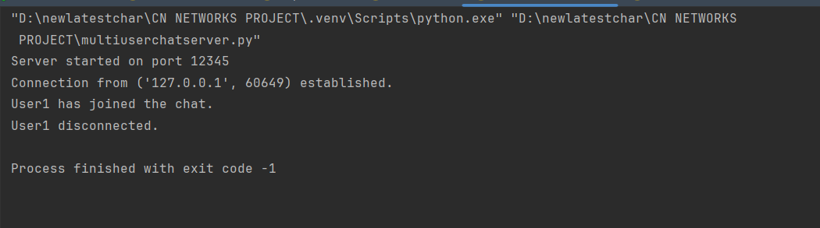

Client output:

